## mlew logo IOT - WORKSHOP

DAY-1

## ELECTRONIC COMMUNICATION ENGINEERING [ECE]

## TEAM MEMBERS:-

Ch.Alekhya Gayatri (24KE5A0404)

E.Hima Bindu (24KE5A0406)

Trisha (24KE5A0405)

priya (23KE1A0450)

Siva parvathi (23KE1A0431)

## TEAM NAME:-SMART CREATORS



#### INTRODUCTION TO IOT:-

* IOT means the THINGS ARE COMMUNICATED BY THE INTERNET and REQIRED OPERATIONS ARE MADE.
* The internet of things(IOT) refers to a vast network of interconnected physical devices,object and systems that are embedded with sensors.
* IOT is a 4D technology. Then the 4D’s are:

1. Data collection
2. Data storage
3. Data visualization
4. Data analysis

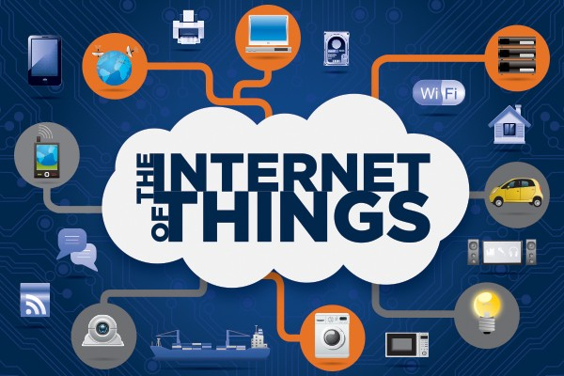

## TYPES OF MICROCONTROLLERS :-

Here are the some comparistion micro controller boards between ARDUNIO UNO, ESP32, ESP8266 and Raspberry pi

#### ARDUINO UNO:-

* It does’t have built -in Wifi module.
* Analog pin are from A0 to A5 in arduino uno.
* Digital pin are from 0 to 13 in arduino uno.
* The common terminals GND terminal is connected to GND and VCC teminal is connected to power are common.

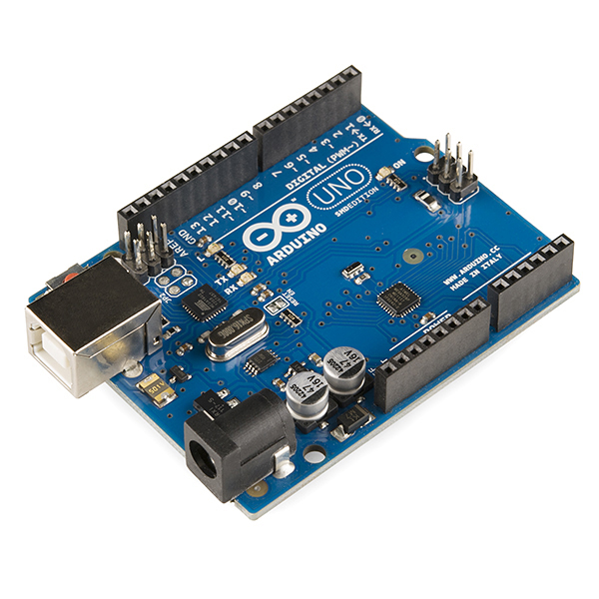

#### ESP8266:-

* It have built - in Wifi module.
* In ESP8266 only one analog pin only that is, A0.
* In ESP8266 have digital pins from D0 to D8.
* In the common terminals VCC terminal is connected to power and GND terminal is connected to GND.

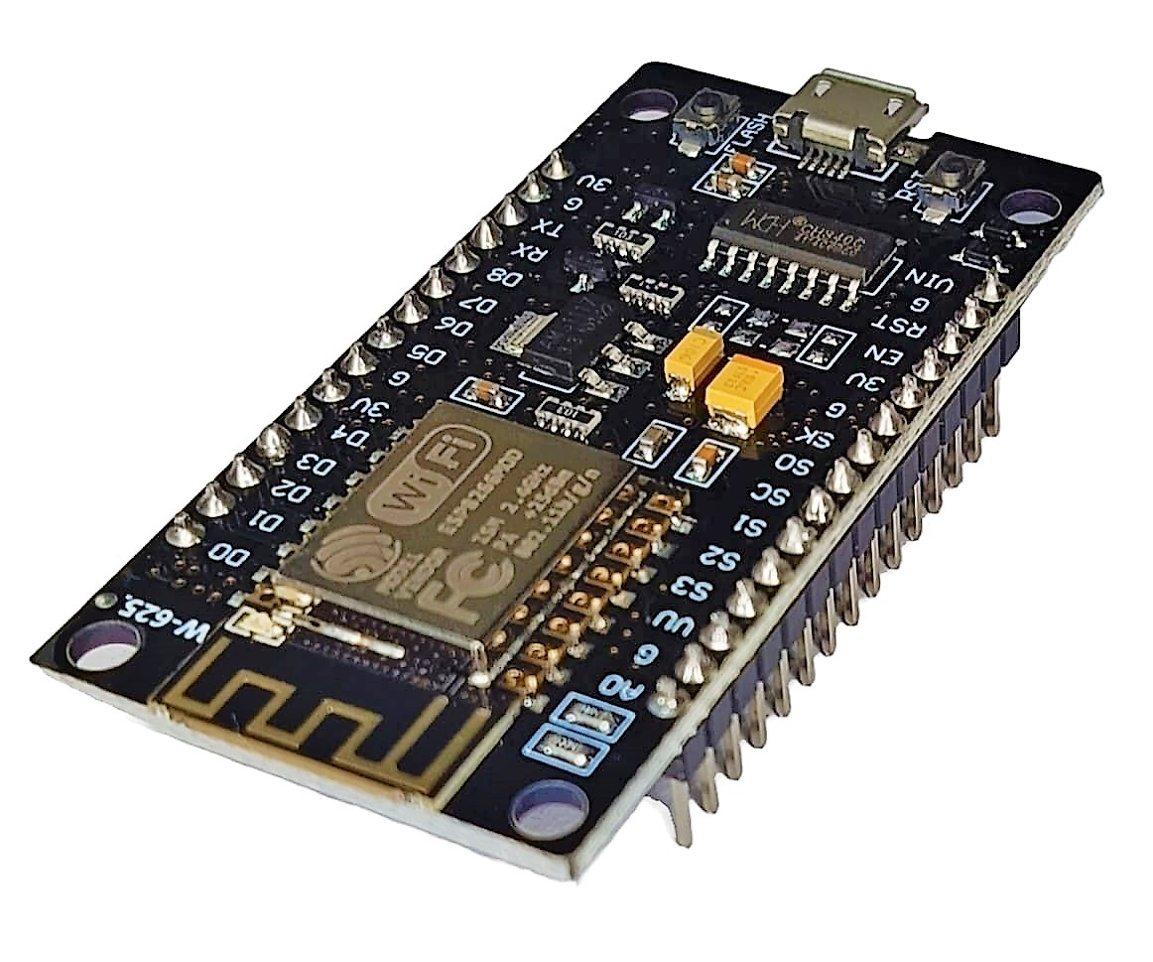

#### ESP32:-

* It have both WIFI and BLUETOOTH IN-Built module.
* Analog pins are from above all the pins of PIN-32.
* Digital pin are from below all the pins of PIN-32.
* In the common terminals VCC terminal is connected to power and GND terminal is connected to GND.

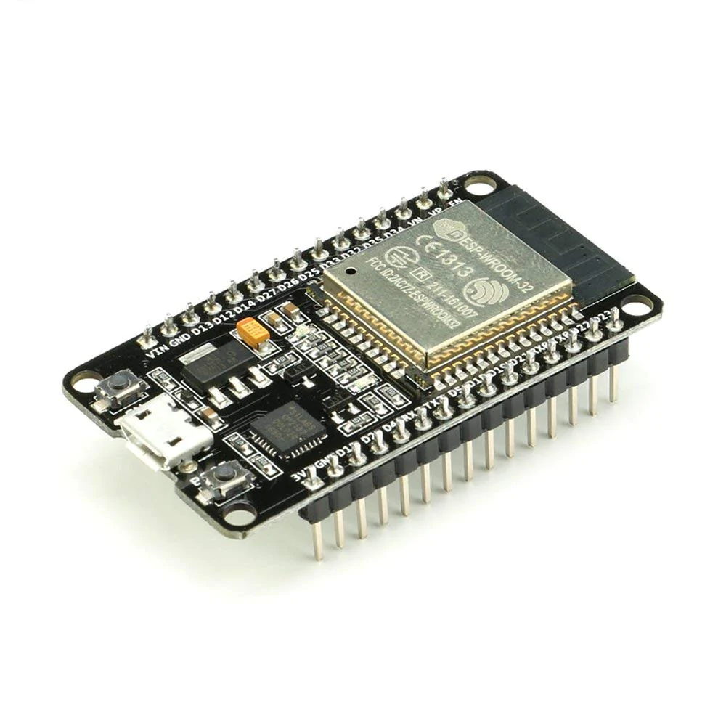

### SENSORS:-

* Sensor is a electronic device which is used to sence the data in environment and stores the data
* There are so many sensor here we are discussing some of them.

#### SOIL MOISTURE SENSOR:-

* It detects the level of moisture present is the soil.
* Moisture sensor is analog sensor.
* It has three pins I.e,

#### AO GND VCC

* CONNECTIONS:-
* Ao PIN is connected to the any analog pin.
* GND PIN is connected to the GND.
* VCC PIN is connected to the power

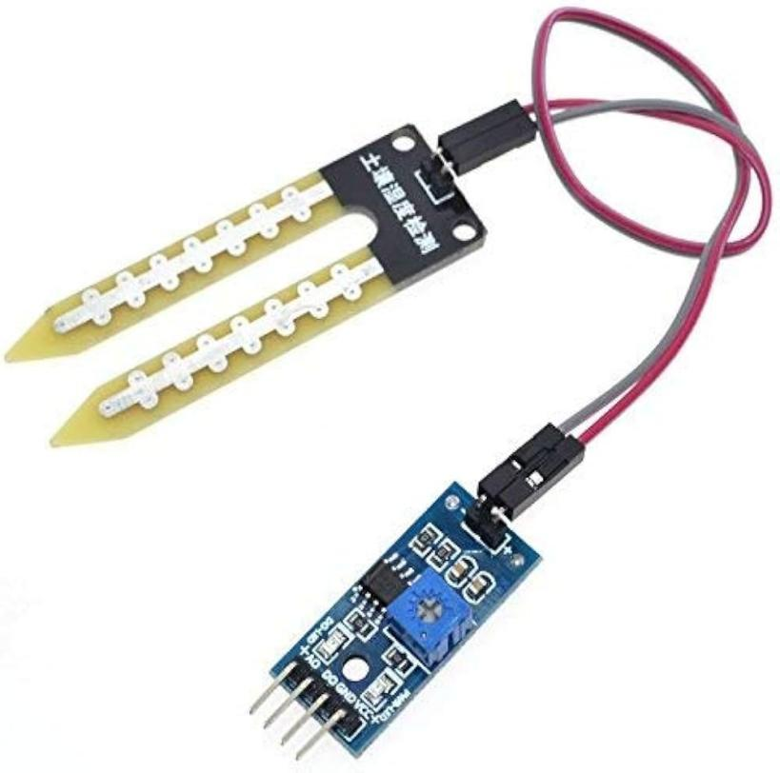

#### ULTRA SONIC SENSOR:-

* It detects the distance of the object.
* The ultra sonic sensor is a DIGITAL sensor.
* It has four pins I.e,

TIRG ECHO GND VCC

* CONNECTIONS:-
* Trig PIN is an input pin and it is connected to any DIGITAL PIN.
* ECHO PIN is an output pin and it is connected to any DIGITAL pin.
* GND PIN is connected to GND.
* VCC PIN is connected to the POWER SUPPLY.

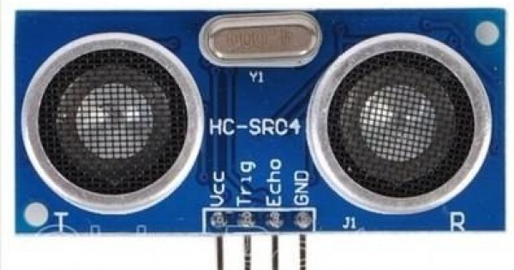

#### LDR (LIGHT DEPENDENT RESISTOR) SENSOR:-

* it measures the intensity or presence of light.
* LDR sensor is a DIGITAL SENSOR.
* It has four pins I.e,

D0 GND VCC

* CONNECTIONS:-
* DO PIN is connected to the any DIGITAL PIN.
* GND PIN is connected to the GND.
* VCC PIN is connected to the POWER SUPPLY.

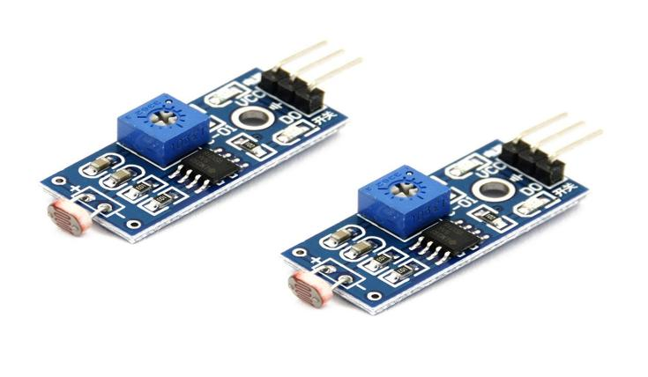

#### HUMIDITY SENSOR (DH11) :-

* Measures the moisture content and humidity and also temperature in the air.
* The HUMIDITY SENSOR is a DIGITAL SENSOR.
* It has three PINS I.e,

D0 GND VCC

* CONNECTIONS:-
* The D0 PIN Is connected to the any DIGITAL PIN.
* The GND PIN is connected to the GND.
* The VCC PIN is connected to the POWER SUPPLY.

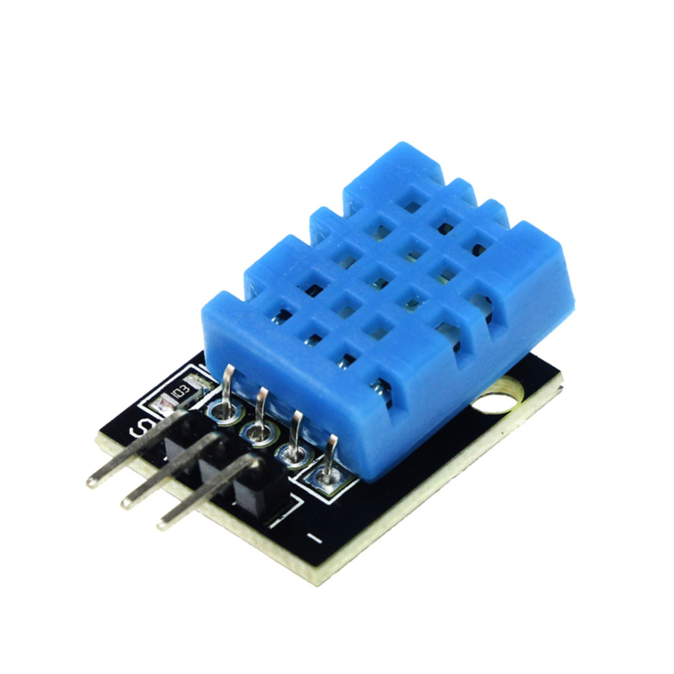

#### GAS SENSOR:-

* It detects and measures the concentration of harmfull gasses.
* The GAS SENSOR is an ANALOG SENSOR.
* It has three pins I.e,

A0 GND VCC

* CONNECTIONS:-
* The A0 PIN is connected to the any ANALOG PIN.
* The GND PIN is connected to the GND.
* The VCC PIN is connected to the POWER SUPPLY.

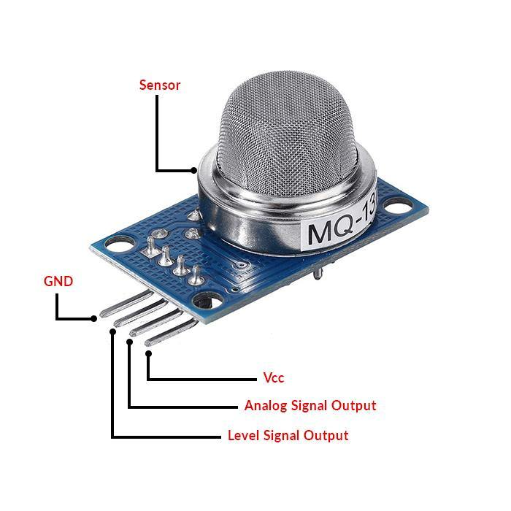

#### ALCOHOL SENSOR:-

* it is designed to detect and measure the presence of alcohol concentration.
* The ALCOHOL SENSOR is a ANALOG SENSOR.
* It has three pins I.e,

A0 GND VCC

* CONNECTIONS:-
* The A0 PIN is connected to the any ANALOG PIN.
* The GND PIN is connected to the GND.
* The VCC PIN is connected to the POWER SUPPLY.

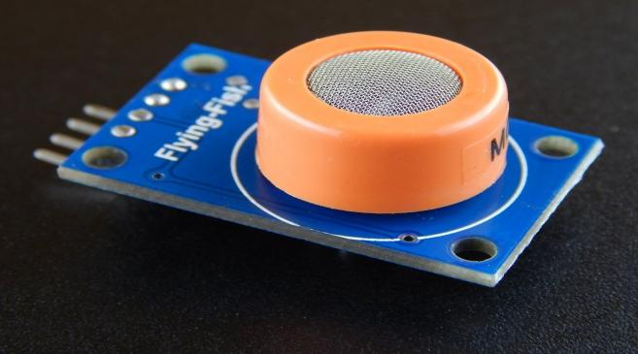

## ACTIVITY:1

## INSTALL THE ARDUINO SOFTWARE AND ALSO INSTAL ESP32 BOARD ON ARDUINO SOFTWARE

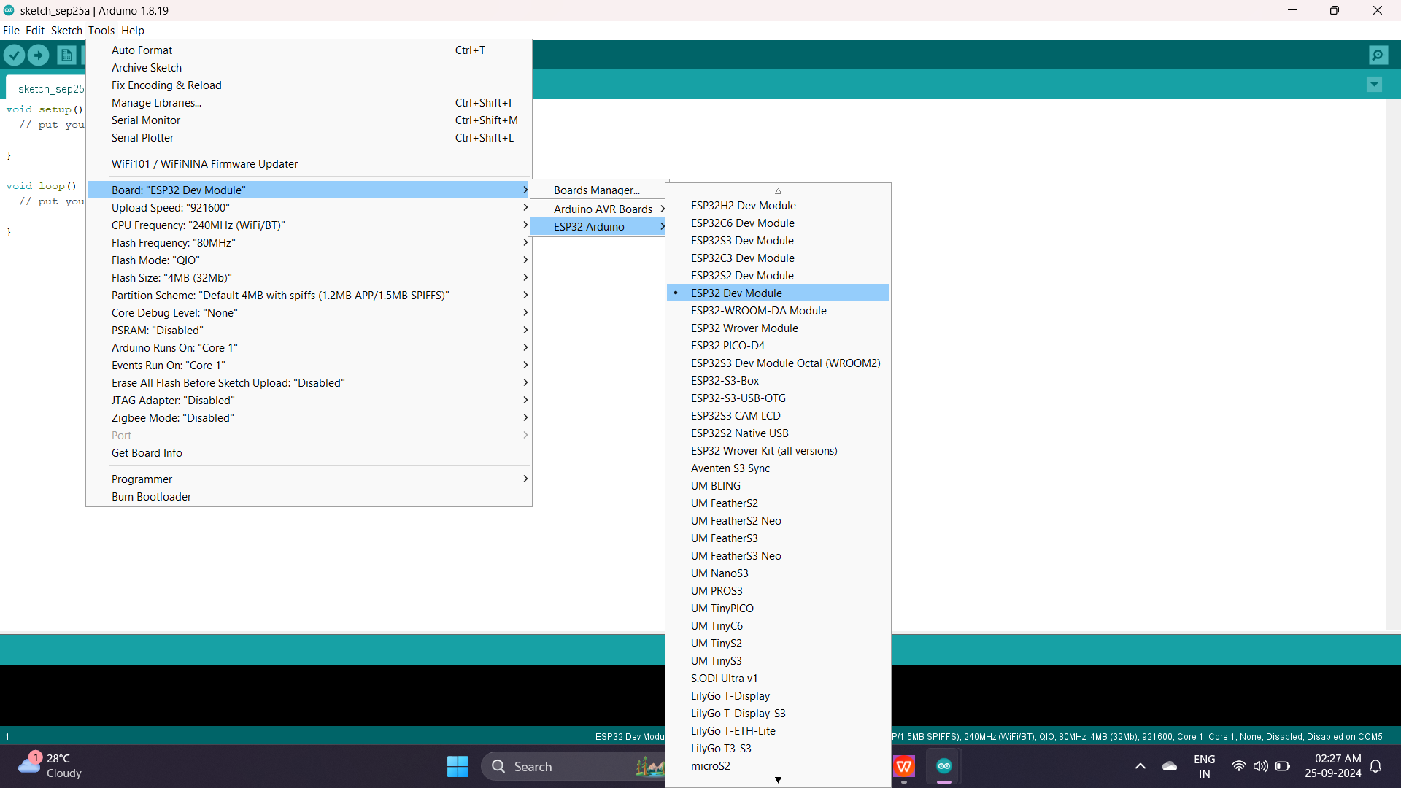

* After the installation of ESP32 board we have select the ESP32 Dev Module shown on above picture.

## ACTIVITY :2

## Print your team members names on serial monitor:

## COMPONENTS REQUIRED:

* ESP32
* USB CABLE
* ESP32:
* It have both WIFI and BLUETOOTH IN-Built module.
* Analog pins are from above all the pins of PIN-32.
* Digital pin are from below all the pins of PIN-32.

In the common terminals VCC terminal is connected to power and GND terminal is connected to GND.



## USB CABLE:

* usb cable is used to connect ESP32 to LAPTOP.

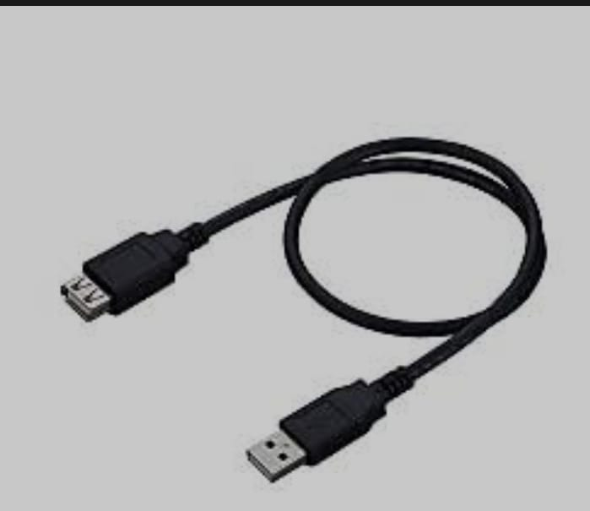

## CODE:

void setup() {

Serial.begin(9600);

// put your setup code here, to run once:

}

void loop() {

Serial.println("Alekhya");

Serial.println("Hima bindu");

Serial.println("Priya");

Serial.println("trisha");

Serial.println("siva parvathi");

// put your main code here, to run repeatedly:

}

* After writing the code we have to complie the code.
* After that connect usb cable laptop to esp32 we have to dump the code into ESP32.
* Check the output across serial monitor as shown below:

### OUTPUT:

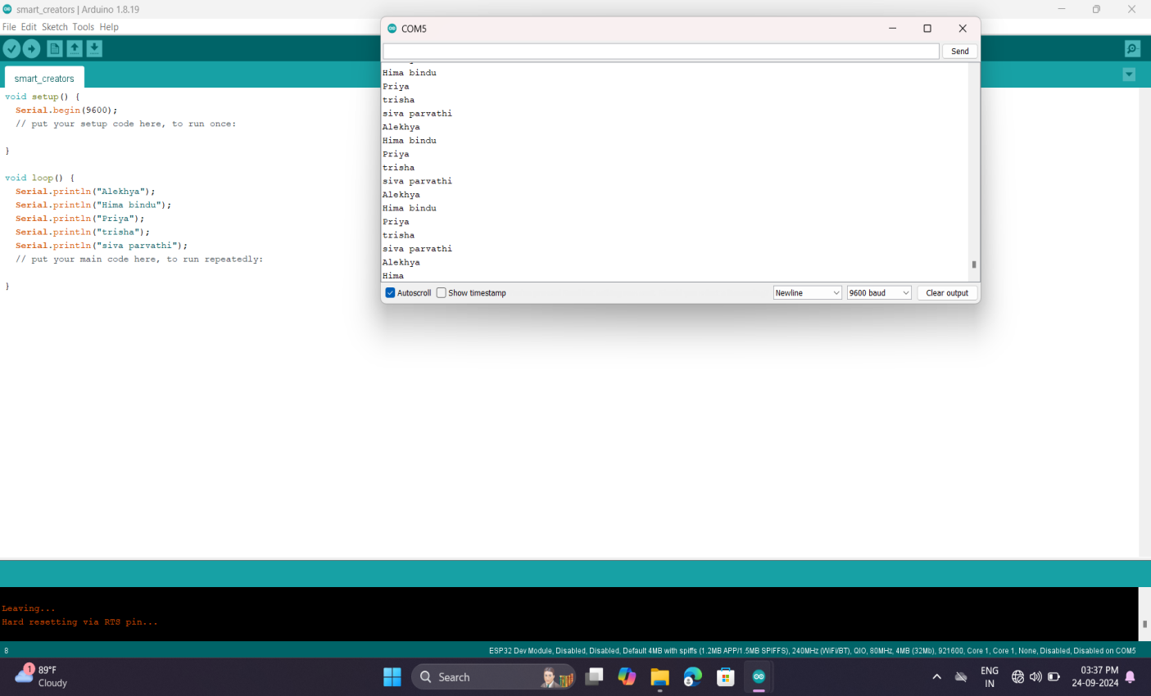

## ACTIVITY:3

## PRINT LDR SENSOR MONITOR OR SERIAL MONITOR

## COMPONENTS REQUIRED:-

* ESP32
* USB CABLE
* LDR SENSOR

## CONNECTIONS:-

* The D0 PIN of the LDR sensor is connected to the 12 PIN of the ESP32.
* The VCC pin of the LDR sensor is connected to the VIN of the ESP32.
* The GND PIN of the LDR sensor is connected to the GND of the ESP32.
* Before the connections we have to dump the code ESP32.

## CODE:-

* int ldr = 12;
* void setup() {
* pinMode(ldr,INPUT);
* Serial.begin(9600);
* // put your setup code here, to run once:
* }
* void loop() {
* int g = digitalRead(ldr);
* Serial.println(g);
* // put your main code here, to run repeatedly:
* }

## OUTPUT:-

* After writing the code we have to complie the code.
* After that connect usb cable laptop to esp32 we have to dump the code into ESP32 with out any connections.
* After that dumping the code we have to connect the connections.
* After that we have connect usb cable again to the laptop to ESP32.
* Check output on serial moniter the output is 0 when LDR sensor detects the light the output is shown bellow.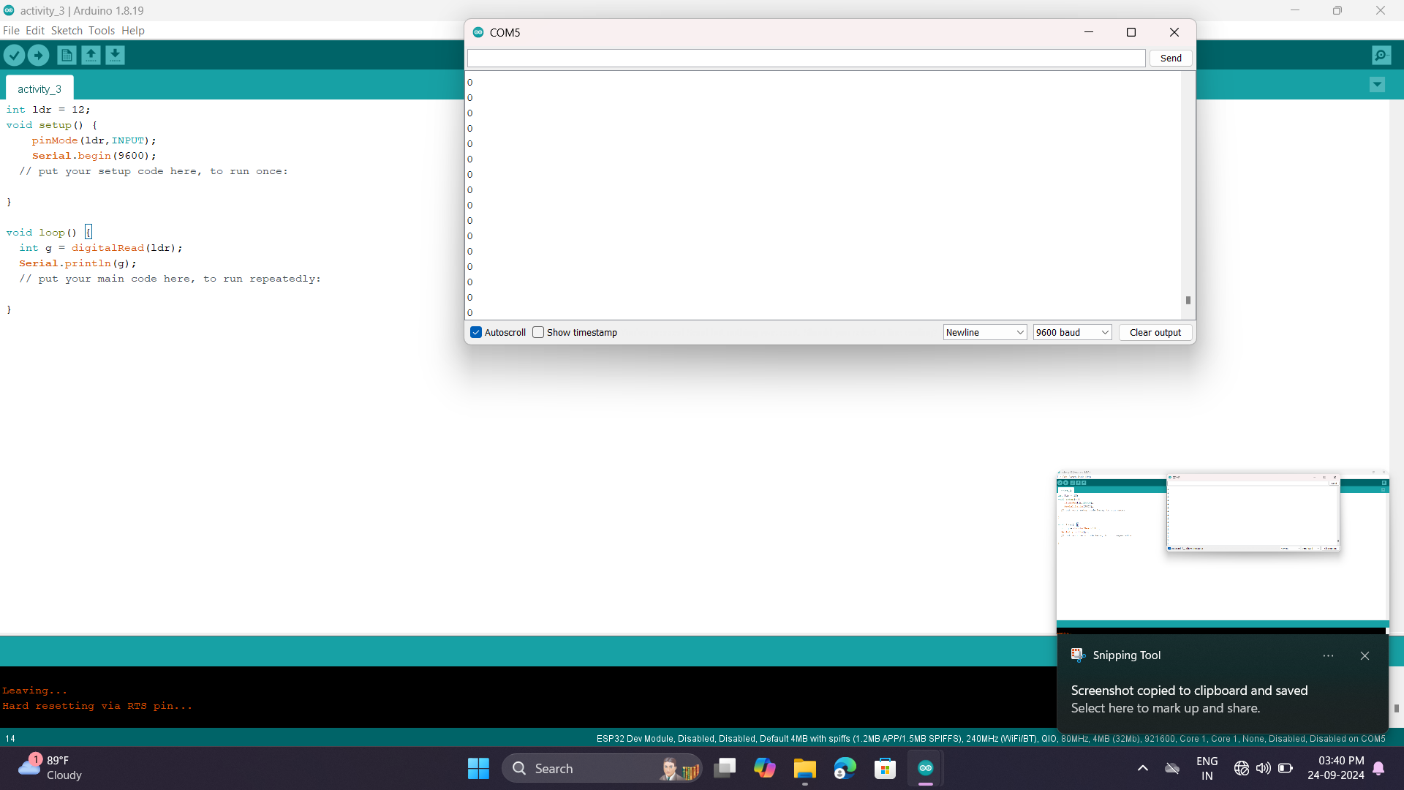
* The output is 1 when the LDR not detects the light and the output is shown bellow.

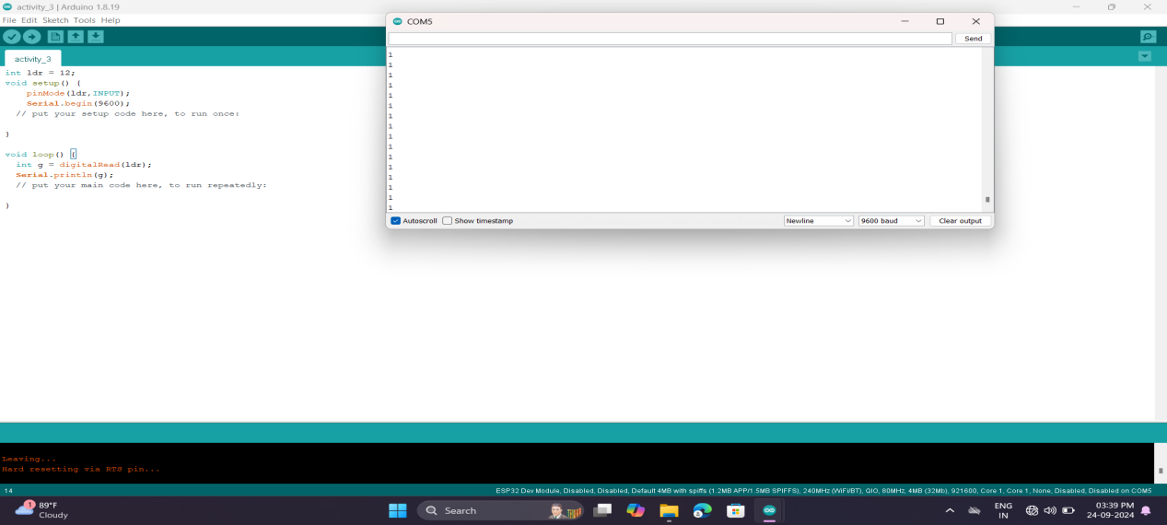

## ACTIVITY:4

## COMPONENTS REQUIRED:-

* ESP32
* USB CABLE
* LDR SENSOR

## CONNECTIONS:-

* The D0 PIN of the LDR sensor is connected to the 12 PIN of the ESP32.
* The VCC pin of the LDR sensor is connected to the VIN of the ESP32.
* The GND PIN of the LDR sensor is connected to the GND of the ESP32.
* Before the connections we have to dump the code ESP32.

## CODE:-

* int ldr = 12;
* void setup() {
* pinMode(ldr,INPUT);
* Serial.begin(9600);
* // put your setup code here, to run once:
* }
* void loop() {
* int g = digitalRead(ldr);
* Serial.println(g);
* if(g==1){
* Serial.println("Dark detected");
* }
* else{
* Serial.println("Light detected");
* }
* // put your main code here, to run repeatedly:
* }

## OUTPUT:-

* After writing the code we have to complie the code.
* After that connect usb cable laptop to esp32 we have to dump the code into ESP32 with out any connections.
* After that dumping the code we have to connect the connections.
* After that we have connect usb cable again to the laptop to ESP32.
* Check output on serial moniter the output is 0 and print the statement’ LIGHT DETECTED’ when LDR sensor detects the light the output is shown bellow.

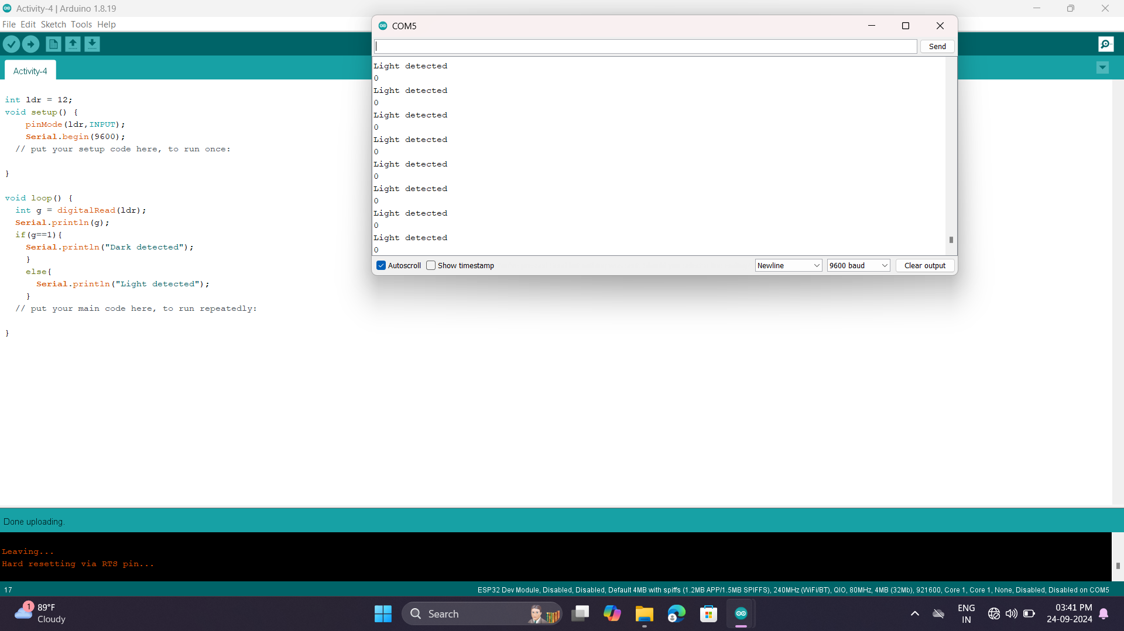

* The output is 1 and prints the statement’ Dark Detected ‘when the LDR not detects the light and the output is shown bellow.

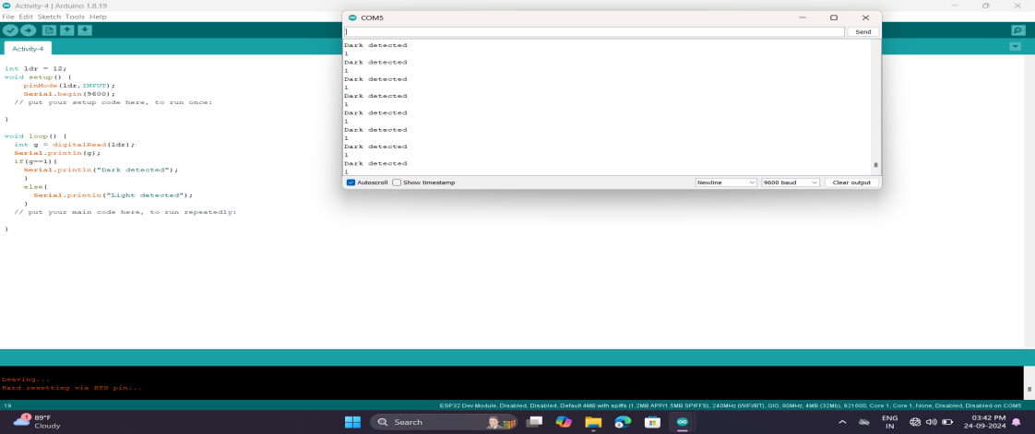

## ACTIVITY:5

## COMPONENTS REQUIRED:-

* ESP32
* USB CABLE
* BUZZER

## CONNECTIONS:-

* The + PIN of the buzzer is connected to the 12 PIN of the ESP32.
* The - PIN of the buzzer is connected to the GND of the ESP32.
* Before the connections we have to dump the code ESP32.

## CODE:-

* int buzzer = 12;
* void setup() {
* pinMode(buzzer,OUTPUT);
* // put your setup code here, to run once:
* }
* void loop() {
* digitalWrite(buzzer,1);
* delay(5000);
* digitalWrite(buzzer,0);
* delay(5000);
* // put your main code here, to run repeatedly:

}

## OUTPUT:-

* After writing the code we have to complie the code.
* After that connect usb cable laptop to esp32 we have to dump the code into ESP32 with out any connections.
* After that dumping the code we have to connect the connections.
* After that we have connect usb cable again to the laptop to ESP32 the buzzer is on 5 seconds and buzzer is of for 5 seconds.

